- Thiessen polygon was applied to assign the available daily weather stations to each CSO community (NPDES). The selection of the daily data locations were based on the proximity to the CSO communities and the temporal completeness of the precipitation data during the period from 1985 through 2008. The table below shows the assignment of the weather stations to NPDES. The figure below shows the spatial representations of the polygons, the weather stations, and the CSO communities.

Table 1. The assignment of the weather stations to NPDES
Weather stations-coop ID | NPDES | Weather stations-coop ID | NPDES
8906 | DC0021199 | 9705 | PA0026557
3570 | DE0020265 | 9933 | PA0026743
3570 | MD0020249 | 9705 | PA0026921
3570 | MD0021571 | 0130 | PA0027014
8065 | MD0021598 | 0130 | PA0027022
0465 | MD0021601 | 8469 | PA0027049
3570 | MD0021636 | 8469 | PA0027057
3570 | MD0022764 | 9705 | PA0027065
8065 | MD0067384 | 9705 | PA0027081
8065 | MD0067407 | 9705 | PA0027090
8065 | MD0067423 | 9933 | PA0027197
8065 | MD0067547 | 9705 | PA0027324
0687 | NY0023981 | 8469 | PA0028631
0687 | NY0024406 | 0130 | PA0028673
0687 | NY0035742 | 8469 | PA0036820
9705 | PA0020940 | 4030 | PA0037711
9933 | PA0021237 | 8469 | PA0038920
0130 | PA0021539 | 0130 | PA0043273
9933 | PA0021571 | 8469 | PA0046159
8469 | PA0021687 | 0106 | PA0070041
9072 | PA0021814 | 0106 | PA0070386
4030 | PA0022209 | 9705 | PAG062202
9705 | PA0023248 | 9933 | PAG063501
0106 | PA0023558 | 5120 | VA0024970
0687 | PA0023736 | 8906 | VA0025160
0687 | PA0024341 | 7285 | VA0025542
9705 | PA0024406 | 7201 | VA0063177
9705 | PA0026107 | 6163 | WV0020150
0130 | PA0026191 | 6163 | WV0021792
8469 | PA0026310 | 4030 | WV0023167
9705 | PA0026361 | 8065 | WV0024392
9705 | PA0026492 | 8065 | WV0105279

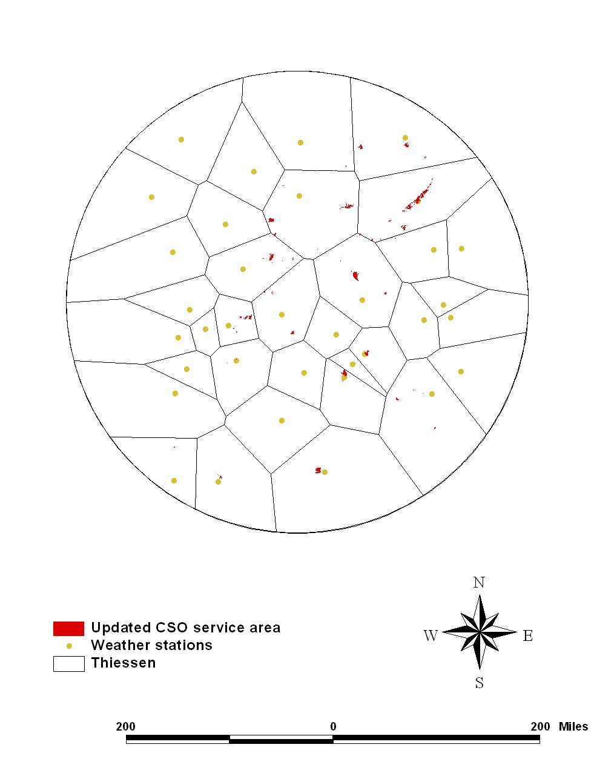
Figure 1. The method (Thiessen polygons) used to determine weather stations assignments to CSO communities

- The daily rainfall data published by EarthInfo, Inc. was accessed. EarthInfo, Inc. is a private company that purchases raw weather data from NCDC. Non available data periods in EarthInfo datasets were supplemented by the data available from NCDC website (http://www.ncdc.noaa.gov/oa/ncdc.html). The table below shows the supplement of the web data to the EarthInfo data. The selection of the web data locations were also based on the proximity to the CSO communities and the temporal completeness of the precipitation data during the period from 1985 through 2008.

Table2. The list of the rainfall stations used to develop CSO discharges
Station name | COOP ID(Daily EarthInfo data) | NWS ID(web data) | STATE
ALLENTOWN A-B-E INTL | 106 | 14737 | PA
ALVIN R BUSH DAM | 8469 | 14778 | PA
BALT-WASHGTN INTL AP | 465 | 93721 | MD
BINGHAMTON LINK FLD | 687 | 4725 | NY
GEORGETOWN 5 SW | 3570 | 13781 | DE
HANCOCK | 4030 | 14751 | MD
JOHNSTOWN 2 | 130 | 94823 | PA
MOOREFIELD 2 SSE | 6163 | 93738 | WV
ROANOKE WOODRUM AP | 7285 | 13741 | VA
SAVAGE RIVER DAM | 8065 | 13729 | MD
WELLSVILLE | 9072 | 4751 | NY
WILKES-BARRE SCRANTN | 9705 | 14777 | PA
YORK 1 S FILTER PLAN | 9933 | 14751 | PA
LYNCHBURG MUNI AP | 5120 | 13733 | VA
RICHMOND BYRD AP | 7201 | 13740 | VA
WASHINGTN DC NATL AP | 8906 | 93784 | DC

- Available hard copy data for CSOs and water quality from the following communities were converted to an electrical format: Ashland, Bedford, Cumberland, Lower_Lackawanna, Shenandoah, Mahanoy and Wyoming valley. 108 spreadsheets data for Alleghany Co’s CSO was extracted and combined into a master file.

- Linear regression was applied to the precipitation (if multiple records are available within the same community, an average of the data was used) and the available CSO discharge (the summation of all discharges from different outlets)data (see Table 3 for R^2).

Table 3. R^2 of the developed linear regression using rainfalls and CSO discharges for NPDES
NPDES | R^2
MD0067407 | 0.6
PA0023558 | 0.85
PA0022209 | 3.00E-06
MD0021598 | 0.67
PA0026361 | 0.56
PA0070386 | 0.13
PA0070041 | 0.03
PA0026107 | 0.18

The data sets with R^2 values higher than 0.5( MD0067407, PA0023558, MD0021598, and PA0026361) were selected for further analysis. CSO discharge data from the selected four data sets were divided by the corresponding community areas to calculate unit area flows (gallon/day-acre). After the unit area flows were derived, correlations were sought between the flows and the associated rainfall data by generating a best fit line. Figure2 shows the result and R^2.

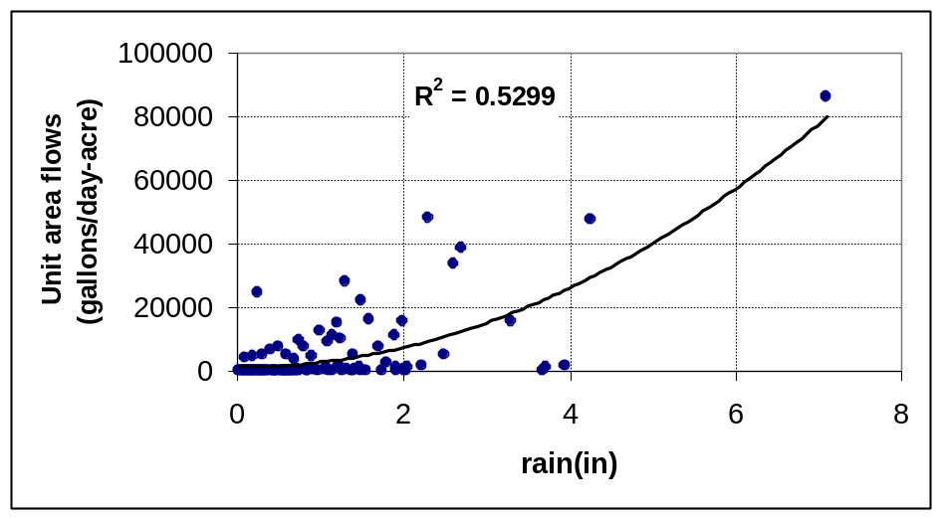
Figure 2. The best it line between unit area CSO discharges and rainfalls

Potentially, an application of the derived regression equation to the selected rainfall data could trigger CSO with small rainfalls as the equations don’t discriminate the small rain falls. Therefore, a cutoff rainfall rate was forced to explicitly eliminate the CSO events for the small rainfalls. The cutoff rainfall rate was determined to be the lowest observed rainfall data generating the observed CSO events for the selected four data sets. The best fit equation and the cutoff rate was applied to the assigned rainfall data for each CSO community and results were multiplied by the community(NPDES) areas to generate the estimated CSO discharges for each NPDES.

- CSO offline periods were also determined to be the following. The facilities after the offline date were generating no CSO events.

Table 4. CSO offline periods
NPDES ID | Facility Name | CSO offline date | interpretation | Suggested further interpretation
MD0021571 | CITY OF SALISBURY WWTP | 2006- Greg Stevens responded 11/6/09 that all former CSO stormwater is routed to the WWTP. | no CSO discharges for 2006,2007,2008&2009, all to WWTP
PA0020940 | TUNKHANNOCK BORO MUN AUTH | 002: 9/21/2000, 003: 12/30/2003. | no detailed information so 50% of CSO was reduced after 9/21/2000 and all CSO was eliminated after 12/30/2000
PA0023558 | ASHLAND WWTP | CSO4 offline 8/08- stormwater sent to WWTP. | CSO eliminated for 8//1/2008-12/31/2009, all to WWTP
PA0024341 | CANTON BORO AUTH WWTP | 2007- former CSO stormwater now discharges directly to Towanda Creek | no CSO discharges for 2007 & 2009
PA0036820 | GALETON BOROUGH AUTHORITY WWTP | 2007, 2008 | no CSO discharges for 2007 - 2009
PA0037711 | EVERETT AREA WWTP | 2007- see 11/3 email for current distribution of stormwater | no CSO discharges for 2007 - 2009 | 2007,2008 &2009, 60%(3 out of 5 CSO eliminated according to the email) of the estimated CSO by a surrogate regression can be categorized as "To WWTP discharges" and 40% could be assumed to be "CSO discharges".
PA0043273 | HOLLIDAYSBURG STP | 002 eliminated 2002- all stormwater flows routed to WWTP. | no CSO discharges for 2002-2009, all to WWTP
PA0070041 | MAHANOY CITY SEWER AUTH WTP | pre- 2003 for 003 and 004- see email archive for current stormwater distribution information. | no CSO discharges for 2003-2009 | from 2003, during wet weather 0.95MGD goes to WWTP and the rest goes to CSO discharges
VA0025542 | Covington Sewage Treatment Plant | 1999- former stormwater discharges directly to river. | no CSO discharges for 1999-2009
WV0021792 | PETERSBURG, CITY OF | not provided- 2003 removed from list of CSO communities. Stormwaters now sent to receiving waters- not WWTP. | no CSO discharges for 2003-2009

- Averaged water quality data for nutrients and others were available from the following facilities and parameters.

Table 7. The averaged observed CSO parameters and concentrations.
NPDES | NH3 (mg/L) | BOD5 (mg/L) | TSS (mg/L) | TP (mg/L) | TKN (mg/L) | NO2+NO3 (mg/L) | TN (mg/L) | Nitrate as N(mg/L) | Phosphorus as P(mg/l) | Nitrite as N(mg/L) | NH3 as N(mg/L)
MD0021598 | 1.324 | 26.620 | 84.960 | 0.437 | 4.324 | 1.552 | 5.876 | - | - | - | -
PA0026361 | - | 24.219 | 96.418 | - | - | - | - | 1.433 | 0.629 | 0.088 | -
PA0026107 | - | 52.249 | 143.547 | 3.179 | - | - | - | 0.866 | - | 0.601 | 3.778
* Parameter names were left as originally described in the original data sets.

- As one of examples, the following data can be used for the facilities with no CSO WQ data. The data sources: Water Quality: Prevention, Identification, and Management of Diffuse Pollution by Vladimir Novotony/Harvery Olem. 1994. Published from Van Nostrand and Reinhold.

Table8. Nationwide average characteristics of CSOs (Novotony and Olem, 1994)
 | BOD5 (mg/L) | Suspended Solids (mg/L) | TN (mg/L) | TP (mg/L)
Nationwide Average Characteristics of CSOs | 115 | 370 | 9 to 10 | 1.9

Additional water quality information related CSO discharges

Table 9. Report to Congress:Impacts and Control of CSOs and SSOs, U.S.EPA, Office of Water, 20044
 | BOD5 (mg/L) | TSS (mg/L) | TP (mg/L) | TKN (mg/L)
Number of samples | 501 | 995 | 43 | 373
Range | 3.9 - 696 | 1 - 4,420 | 0.1 - 20.8 | 0 -82.1
Median | 43 | 127 | 0.7 | 3.6

Table 10. Limno Tech D.C. study (1985-2005)
TSS(mg/L) | Total N(mg/L) | Total P(mg/L)
152.01 | 6.55 | 1.21

